F21AA - Applied Text Analytics - Coursework 1
__________________________________________________________________________________________
Submitted by:
Name | ID | Email | Program | Contribution
Gabi Mansour | H00313528 | gj12@hw.ac.uk | MSc - AI | Steps 1, 2, 3, 6
Vimal Vidyadharan | H00316629 | vv30@hw.ac.uk | MSc - AI | Steps 1, 2, 3, 6
Omar Hemsi | H00331226 | obh2@hw.ac.uk | MSc - Data Science | Steps 4, 5, 6
Khaled Aldhaheri | H00337352 | kma4@hw.ac.uk | MSc - AI | Steps 4, 5, 6

Coursework Scenario
We have a dataset of 426k text reviews of fine foods provided by the users of Amazon. Reviews include product and user information, ratings, and a plaintext review.
The ratings score different food products to 1 (low rating) up till 5 (maximum rating).This can be considered a multi-class classification problem where the classes are the scores provided by the user {1, 2, 3, 4, 5}. The features are the text reviews.
We have to use ‘analytics’ skills to provide insights on the data provided and to propose a categorization system that can automatically rate similar text reviews.

Proof/Code: We used Python language for this coursework. All files and codes are available in the folder: ATA_CW1_GABI_ET_ALL on HeriotWatt Drive

Data Exploration and Visualization
We imported all the libraries required to process the dataset file ‘train.csv’: nltk, sklearn, numpy, pandas, etc. We also imported “Pool” from “multiprocessing” library and defined “execute_in_parallel” method to execute functions in parallel and speed up the processing.
We read the file, and found it having these features: Id, ProductId, UserId, ProfileName, HelpfulnessNumerator, HelpfulnessDenominator, Score, Time, Summary, and Text.
The Number of reviewed products are 65858, and the number of users participated are 210008.
Score is the feature that we are going to predict based on the user reviews given in “Summary” and “Text” features. Score values are distributed as per below:
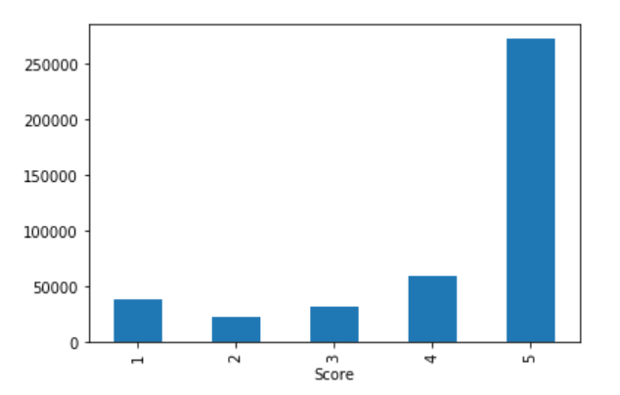
Score | N. of Products
1 | 39193
2 | 22353
3 | 31993
4 | 60309
5 | 272492

HelpfulnessNumerator is the number of users who found the review helpful. HelpfulnessDenominator is the number of users who marked whether the review is helpful or not.
Conclusions:
- The highest score (5) is dominating the other values. This looks normal as most of users know the quality of the product before they buy it from Amazon, and might be already referred to it by other users. Also, they tend to select the highest score when they like the product.
- The features, required for our model, are Score, Summary, and Text. So we can drop the rest, and concatenate Summary and Text in a new feature.

Text Processing and Normalization
We processed the data by doing the following steps:
- Remove duplicates based on the subset (UserId, Score, Summary, Text), using “drop_duplicates” method. Instances were reduced by 27.5% to 309191 instances.
- Replace ‘NA’ by spaces in Summary and Text features, using “fillna” method.
- Concatenate Summary & Text into a new feature “Review”.
- Clean “Review” by removing HTML tags using “BeautifulSoup” library, and removing numbers, [], &, -, _, using “re.sub” method.
- Keep Id, Score, Time, and Review features and drop the rest.
Post that, data had below format:
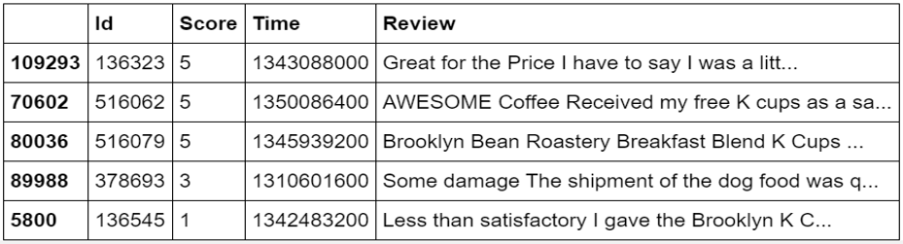
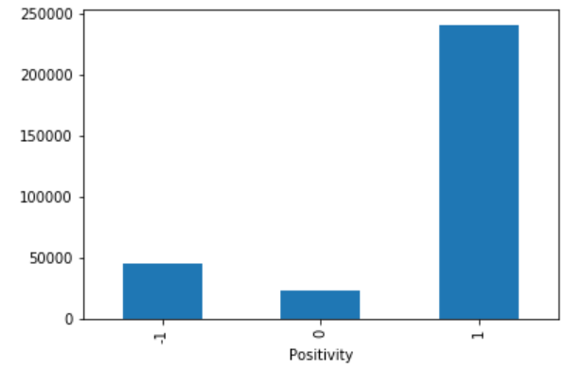
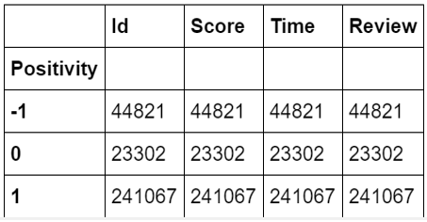
- Introduce a new feature “Positivity”, so reviews with score more than 3 are positive, and below 3 are negative, 3 is neutral. Positive gets +1, negative -1, and neutral is 0. The data got this shape:

- Tokenizing and stemming using 3 types of stemmers: PorterStemmer followed by SnowballStemmer, then LancasterStemmer, and we generated “stemfile” using “to_csv” method.
PorterStemmer uses suffix stripping to produce stems, and is known for its simplicity and speed.
SnowballStemmer is known as “Porter2”, and is slightly faster than Porter.
LancasterStemmer is simple, but heavy stemming due to iterations and over-stemmineg may occur. Over-stemming causes the stems to be not linguistic, or they may have no meaning.
- Lemmatization using NLTK WordNetLemmatizer, and use “nltk_tag” to tag words as verb, noun, adjective, or adverb. This lemmatized review was added as a new feature “Lemmat” to our dataset, and we also generated a new file “lemfile” using “to_csv” method. We also lemmatized using Spacy library, and it took longer time than NLTK.
Conclusions:
- Stemming returns the words to its spelling e.g. “worse” to “wors”, while lemmatization returns the words to its roots, so we decided to continue working on the NLTK lemmatized review “Lemmat”.
- We compared between the outputs of tokenizers, stemmers and lemmatizers, and we got below result.
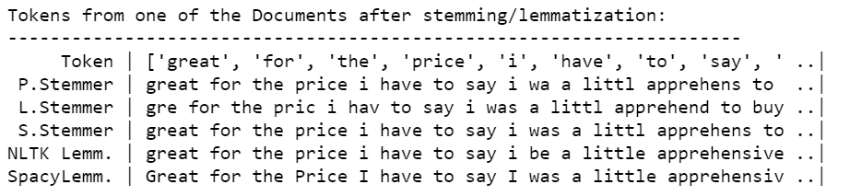

Vectorization and Feature Representation
We used CountVectorizer and TfidfVectorizer, and fitted them to “lemfile”. We created 3 vectors (1-gram, 2-gram, and 3-gram) from each type, with “mindf” as 10, removing stop words, and converting all words to lower case. Below is the code snippet for the 2-gram CountVectorizer.
vect2 = CountVectorizer(min_df=10,lowercase=True,strip_accents='ascii',ngram_range=(1,2)).fittraindf['Lemmat'])
So we got 6 vectors and we got the feature names of each vector using “get_feature_names” method.
We printed the number of features and first and last 100 features of the vectors using below codes.
feature_names = vect1.get_feature_names()
print('No. of features in Uni-gram Vect = ',len(feature_names))
print('First 100 Features are: \n{}'.format(feature_names[:100]))
print("Last 100 Features:\n{}".format(feature_names[100:]))
We also compared the number of features between the vectors, and got below result.
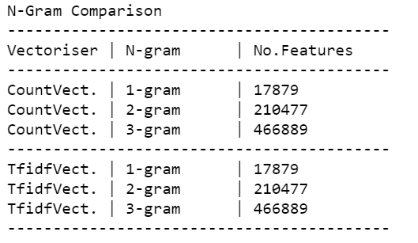
Then we defined the “y_train” and “x_train” parameters for the training models, where “y_train” is the score, and “x_train” is the lemmatized review, fitted and transformed by the vectors, and we have 6 of them as per below code.
y_train = traindf['Score']
x_train1 = vect1.fit_transform(traindf['Lemmat']) #uni gram
x_train2 = vect2.fit_transform(traindf['Lemmat']) #bi gram
x_train3 = vect3.fit_transform(traindf['Lemmat']) #tri gram
x_tftrain1 = tfvect1.fit_transform(traindf['Lemmat']) #uni gram
x_tftrain2 = tfvect2.fit_transform(traindf['Lemmat']) #bi gram
x_tftrain3 = tfvect3.fit_transform(traindf['Lemmat']) #tri gram
Discussions:
- We set “mindf” to 10 to eliminate the unimportant words that have frequency less than 10.
- Choosing different n-grams can help effectively in this classification problem. For example, if “good product” review has rate (4), the review “very good product” could have (5).
- We have 6 experiments for each training model, and we will compare between them in the next steps.

